Adding to the family

A planning guide to help you navigate benefits and resources at Virginia Commonwealth University



**Adding to the family**

This guide is intended to serve as a resource for VCU faculty and staff who are adding children to their families. This guide provides a general framework and timetable for planning and completing employment and benefit actions. . This guide is not intended to cover every possible scenario, but provides helpful tools and resources for this exciting new journey. If you have any questions after reviewing this guide we encourage you to reach out to your department HR contact for assistance. Unsure who your HR contact is? A list of HR contacts can be found [here](https://hr.vcu.edu/about/contact/hr-contacts-for-schools-and-units/).

The content in this guide applies only to university employment and benefits. If you are simultaneously employed by another VCU-related entity (including but not limited to VCU Health, VCU Dental Care, or MCV Physicians), separate employment and benefits provisions apply to that employment. Please connect with the HR department of your other employer for details about leave and benefits processes applicable to that employment.

**Table of Contents**

Sharing your news and planning for your absence 3

Leave options 4

Leave charts 5

Special Information for MCV Physicians 6

Update leave in Realtime 6

Complete steps for leave usage 7

How leave affects your benefits 8

Flexible work arrangements 10

Prenatal care and maternity programs 10

Need to make a change to your benefits? 12

Well-being resources 14

Checklist 16

# Sharing your news and planning for your absence

You are beginning a very exciting time in your life and have much to consider before your child(ren) arrives, especially if you are planning to take time off. . We’ve learned from experience that the sooner you start your planning, the better prepared you will be for the transition. We encourage you to contact your [HR Professional](https://hr.vcu.edu/about/contact/hr-contacts-for-schools-and-units/) to start planning as soon as possible, especially if you plan to request an adjustment to your work arrangement or a leave of absence.

There are many VCU programs, policies, and resources available to assist employees through birth, adoption, surrogacy or foster care. A list of some of those resources can be found [here](https://hr.vcu.edu/worklife-at-vcu/).

When you are comfortable:

* Share your good news with your team, manager and your [HR Professional](https://hr.vcu.edu/about/contact/hr-contacts-for-schools-and-units/).
* Think about any work adjustments or flexible work arrangements that you plan to request, and discuss with your manager. If you anticipate a need to revise your goals for the year, be sure to discuss that with your manager as well.
* VCU does not unlawfully discriminate on the basis of pregnancy, childbirth, or related medical issues. Contact your [HR Professional](https://hr.vcu.edu/about/contact/hr-contacts-for-schools-and-units/) or manager if you have limitations due to pregnancy, childbirth, or related medical issues for which you need assistance to seek an accommodation. More information about the interactive process and reasonable accommodations for pregnancy can be found on VCU's [ADA Office](https://equity.vcu.edu/ada--accessibility-services/ada-employee-accommodations/)’s website. Employers are prohibited from taking adverse action against an employee who requests or engages in the interactive reasonable accommodation process.
* If you are planning to take leave, begin learning about the leave process and planning for your absence. Use this guide and the checklist to help you. Some additional things to consider when planning your absence include:
  + What work needs to be covered while you are out? Do you supervise staff who will need an interim manager? Discuss these needs with your manager and take proper steps to plan and prepare for your planned absence. You may also want to think about what should happen if you have to go out earlier than expected.
  + Set an out of office message on your email with instructions on who to contact in your absence.
  + Set an out of office greeting on your phone with instructions on who to contact in your absence.

Returning from leave:

* Schedule meetings with your manager(s) and appropriate team members to get caught up on what you missed while you were on leave.
* Cancel your out-of-office notification. Review your email greeting to see if any changes are required.
* Set realistic goals and expectations of yourself. Use the support of other working parents to help you through the transition.
* Be prepared to reassess your work schedule on a continual basis.
* Communicate honestly with your coworkers, supervisors and others about your needs. People can’t help you unless you tell them what you need.

# Leave options

Speak with your HR Professional or a member of their staff to discuss your leave options.

* Family Medical Leave Act (FMLA) - provides unpaid job protection for up to 12 weeks for eligible VCU employees who are expecting a baby. It is important to note that this simply provides protection for your job and benefits and does not serve as income replacement. For faculty in VRS, for University & Academic Professionals, and for classified staff in VSDP, this should be used in conjunction with short-term disability for the birthing parent. Your HR Professional or member of their staff will work with you to complete the necessary steps for this.
* Short-Term Disability (STD) - Available to eligible VCU employees who are the birthing parent. Short-term disability provides income replacement for employees while they are medically incapacitated. This benefit runs concurrently with FMLA, if applicable. Short term disability benefits for the birthing parent usually extend for 6-8 weeks subject to approval by the third-party benefit administrator. You must initiate your claim directly with the vendor and your HR team can help to provide you with that information.
* Parental Leave - Available to eligible VCU University & Academic Professionals and classified staff with at least one (1) year of service. It provides 100% income replacement for employees for six (6) to eight (8) weeks. This program also runs concurrently with FMLA if applicable, and is typically used after the STD period ends. Your HR Professional or member of their staff will work with you to complete the necessary steps for this.
  + University and Academic professionals receive 240 hours (6 weeks) of Parental Leave which must be used within a year of the baby’s birth.
  + Classified employees receive 320 hours (8 weeks) of Parental Leave which must be used within 6 months of the baby’s birth.
  + Medical documentation is not required for the approval of this leave program if the child has been added to the employee’s health coverage plan. If the child is not being added to the employee’s health coverage plan, a proof of birth/relationship is required for approval.
* Annual Leave - This leave is available to faculty and classified staff for birthing and non-birthing parents to use to supplement their unpaid FMLA leave.
* Traditional Sick Leave- Faculty and classified staff in the traditional sick leave program may use this leave for childbearing purposes. Sick leave is applicable for the birthing parent for the time period they are medically disabled (normally 6 weeks). A portion of it can also be used for a non-birthing parent during FMLA for family reasons.
* More details about paid and unpaid leave options available to birthing and non-birthing parents based on employee classification can be found below.
* 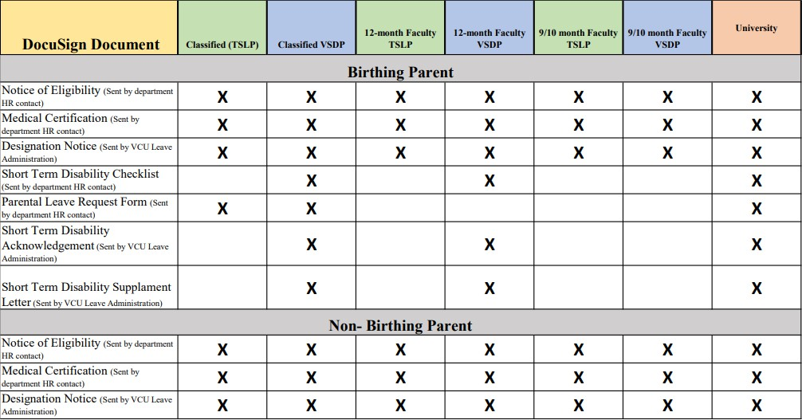Birthing and Non-Birthing parents will be receiving multiple leave documents from both their department and VCU Leave Administration. The chart below shows what documents the employee should expect to receive.

**Leave options chart**

Below is a chart that provides available paid and unpaid options for the birthing and non-birthing parent based on employee classification. If you are unsure of your employee classification please contact your department’s HR representative.

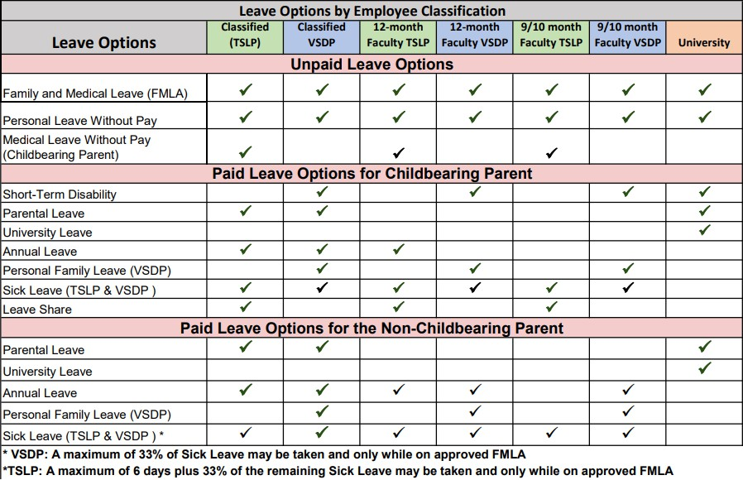

# Special Information for MCV Physicians

If you are also employed by MCV Physicians, please see the attached M1 and O1 Leave Flow Chart for more information on the Parental and Medical Leave Process for Clinical Faculty Employed by VCU and MCV Physicians (MCVP)

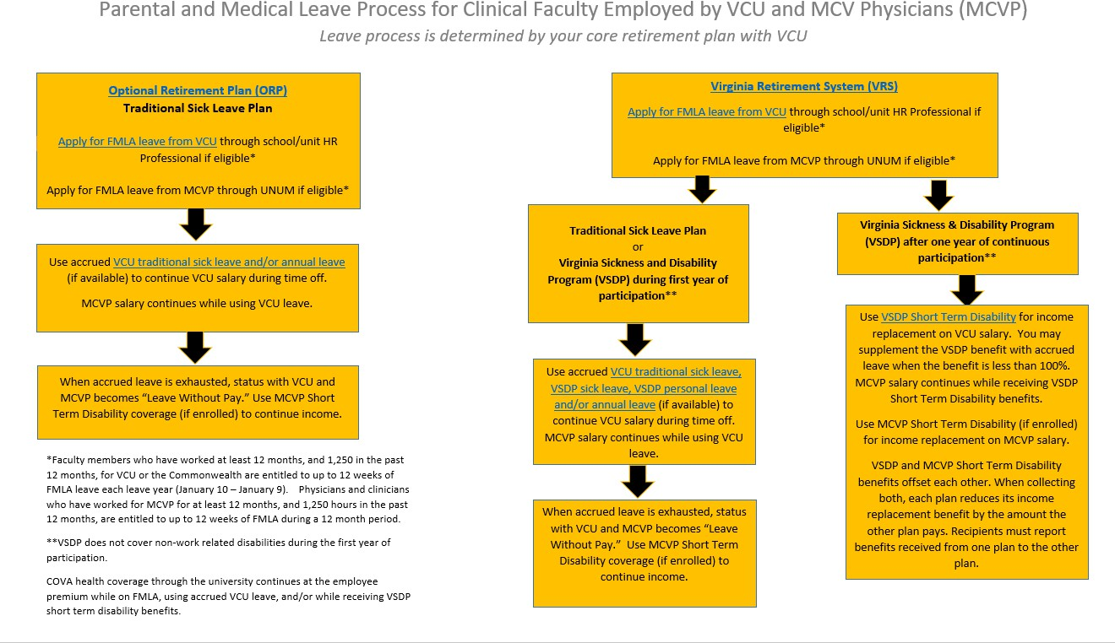



[M1 and O1 Leave Flow Chart (1)](https://docs.google.com/document/d/1rqa_4mcvCauV-riSeGf1YbH4fK0XhTAyL0UFF0W0Hxs/edit?usp=sharing)

# Update Leave in RealTime

Prior to your planned leave, submit parental or other personal leave requests in RealTime for the expected absence. If you are out on Short Term Disability (STD), remember to request your 40 hours of paid leave to meet the waiting period requirement. As we know, children do not always arrive on time, so while you are out it is important to make note of the [payroll deadlines](https://hr.vcu.edu/current-employees/payroll/) and ensure your leave is submitted correctly based on when you actually go out on leave.

Once you begin your leave, you should notify your immediate supervisor, HR contact, and short-term disability vendor as soon as you are able to do so. These people can help ensure your leave is accurate in RealTime.

If using STD, the benefit company will update your claim and provide the approved dates to VCU. During this time (typically 6-8 weeks), VCU Leave ([leave@vcu.edu](mailto:leave@vcu.edu)) manages your timesheet and ensures the correct STD leave is used. You do not need to adjust the leave entered for this time period and can contact VCU Leave directly if you

have any questions. *Note: Sometimes the lag between when you notify STD and they notify VCU creates a gap in time where leave may not be entered and this could impact your pay. The waiting period is usually sufficient time to cover any lag, but you can submit more leave if you have not received your STD approval yet to ensure there is no gap in pay. If you are retroactively approved for any dates that you have used your personal leave past the waiting period, VCU Leave Administration will perform a leave audit at the end of your claim and return your used personal leave.

To help you plan out your leave, a typical leave usage schedule is below. Your plan will be specific to your needs and plans.

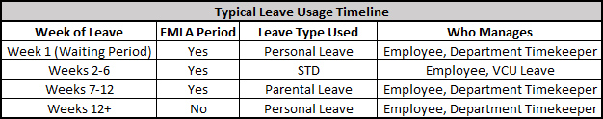

# Complete steps for leave usage

Once the employee has had a chance to learn about their leave options and put their plan together, the employee will want to begin the process to complete the forms to use the applicable leave. The employee’s HR team will help with this piece and, typically, the following steps will be needed:

1. If the employee is the birthing parent they should obtain the FMLA Medical Certification form and provide this to their doctor for completion. Most doctor’s offices charge a fee to complete this form and it can take some time to process with them. Once completed, the employee will submit this back to their HR team. Non-birthing parents may submit a proof of birth or another document that provides proof of relationship (i.e. birth certificate, court order for foster placement, adoption records) to VCU Leave Administration for approval of parental leave.
2. Once returned, the employee’s HR team will use this to complete the applicable DocuSign forms for the employee’s FMLA and parental leave. The employee will also receive these DocuSign documents which require the employee’s attention to be completed.
3. At the same time the employee is obtaining the FMLA form, birthing parents should also connect with their STD vendor to initiate their claim. They also require specific forms and will communicate directly with the employee’s doctor to obtain these. *Please note that VCU is not able to initiate the employee’s claim or respond on their behalf, the employee must communicate with them.*
4. Once approved and processed, the employee may wish to go into RealTime to pre-load their parental leave prior to their departure if the employee is the

non-birthing parent. Parental leave for the birthing parent will be pre-loaded by the VCU Leave Administration team based on the employee’s short-term disability claim dates.

# How leave affects your benefits

Leave may be taken with or without pay. When paid leave is used (including short-term disability for eligible employees), benefits including health coverage, flexible spending accounts, retirement and life insurance continue without interruption. Available paid and unpaid leave options for birthing and non-birthing parents based on employee classification can be found in the Leave Options chart on page 5.

When leave is taken without pay:

* + Health coverage can continue if you continue to remit employee premiums to VCU Payroll by the first of each month during your leave of absence. Unpaid premiums can result in cancellation of coverage so be sure to set up your payments in advance of an unpaid leave. You can choose to waive or reduce your coverage when beginning a leave without pay if you wish. If you waive coverage, no premiums are due for any month you are on unpaid leave as of the first of the month, however coverage is not automatically restored when you return to work and you must actively re-enroll no later than 60 days from returning in order to resume coverage. Coverage resumption is based on the date of your election and cannot be retroactive.
  + Flexible spending accounts can continue if you pre-pay your contributions before your leave starts, or remit contributions to VCU Payroll by the first of each month during your leave of absence. Unpaid contributions can result in cancellation of your account so be sure to set your contributions in advance of going on unpaid leave. You can choose to waive participation when beginning a leave without pay if you wish. If you waive participation your coverage period ends at the end of the month and your participation does not automatically resume when you return to work. You may re-enroll within 60 days of returning in order to participate again on a prospective basis.
  + Virginia Retirement System participants: There are no retirement contributions and no service credit for any month you are on unpaid leave as of the first business day of the month. You can purchase service credit directly from VRS for periods of leave due to the birth or adoption of a child once you return to work.
  + Optional Retirement Plan participants: There are no contributions during leave without pay. Your benefit is not based on service credit.
  + Basic life insurance provided by VCU continues, but if you purchase optional life insurance from your paycheck you must make arrangements directly with Securian to make your premium payments during unpaid leave. Payment cannot be made through VCU when you are not receiving a paycheck.



# Flexible work arrangements

Preparing to go out or returning to work from an extended leave can be challenging and requires a lot of decision-making and juggling, not to mention fortitude. VCU is committed to helping you succeed personally and professionally. One of the many advantages of working at VCU is the quality of our work life. While numerous factors contribute to a positive working environment, a major benefit is flexible work arrangements (FWAs). FWAs allow flexibility in work schedules and location so staff are better able to balance their work and home life while still meeting the needs of the university and supporting an engaged living, learning and working environment.

Employees should visit VCU’s [Flexible work arrangements](https://hr.vcu.edu/current-employees/flexible-work-arrangements/) webpage to determine their eligibility for a FWA. The webpage provides examples and ideas for utilizing FWAs.

If you are interested in learning more about pursuing an FWA, talk to your HR Professional or manager to discuss the options that are available and what might work best for your personal situation. An FWA requires a number of considerations including determining eligibility, developing an agreement, requesting necessary equipment, etc. so plan to have a conversation as soon as you know you would like to discuss this option.

## Prenatal care and maternity programs

Your health plan may offer prenatal care and maternity programs. These programs are designed to help answer your questions, assist you with making good choices and follow your health plan provider’s plan of care. Please consult your member handbook or contact your plan provider to learn more about their offerings for maternity care.

If you are enrolled in the State’s health plan through VCU, please find below the current maternity programs offered through the State health plans.

**COVA Care and COVA HDHP Participants:** [**Anthem Future Moms Program**](https://www.dhrm.virginia.gov/docs/default-source/benefitsdocuments/ohb/cova-future-moms.pdf?sfvrsn=0)If you’re expecting a baby, the Future Moms maternity support program can help you stay well throughout your pregnancy and after your baby is born. You’ll have regular phone calls with your personal Anthem nurse who can help you:

* + Follow a healthy diet and lifestyle;
  + Understand your prenatal tests and the results;
  + Find a specialist if you need one;
  + Recognize the signs of early labor; and
  + Take care of yourself and your newborn after delivery.

[Future Moms](https://www.dhrm.virginia.gov/docs/default-source/benefitsdocuments/ohb/cova-future-moms.pdf?sfvrsn=0) Incentive: If you enroll in Future Moms within the first 16 weeks of pregnancy, actively participate, and comply with all program requirements, your health plan may waive the maternity hospital stay copayment.

**COVA HealthAware Participants:** [**Aetna Maternity Program**](https://www.dhrm.virginia.gov/docs/default-source/benefitsdocuments/ohb/aetna-maternity-program---member-flyer-(pre-enrollment).pdf?sfvrsn=0)

If you’re expecting a baby, the maternity support program can help you stay well throughout your pregnancy and after your baby is born. You’ll have regular phone calls or mailings from your personal Aetna nurse who can help you:

* + Follow a healthy diet and lifestyle;
  + Understand your prenatal tests and the results;
  + Find a specialist if you need one;
  + Recognize the signs of early labor; and
  + Take care of yourself and your newborn after delivery.

Call 1-855-414-1901 to sign up for the program. Your nurse will set up appointments so you can talk throughout your pregnancy, and you can call your nurse any time if you have a question.

Remember: If you enroll within the first 16 weeks of your pregnancy and remain engaged in the program through your 28th week of pregnancy, you will earn a $300 contribution to your HRA.

**Dental Care while pregnant: COVA Care, COVA HDHP, and COVA HealthAware participants**

Healthy Smile, Healthy You Administered by Delta Dental of Virginia Growing evidence confirms the connection between oral health and overall general health. Delta Dental of Virginia's Healthy Smile, Healthy You™ program provides additional benefits for three important health conditions connected to oral health: pregnancy, diabetes and high risk cardiac conditions.

Through the program pregnant members are eligible for one additional Dental cleaning and exam, or periodontal maintenance in addition to the normal plan frequency limits. Consult your member handbook for further details.

**Optima Health participants:** [Partners in Pregnancy](https://www.optimahealth.com/members/health-and-wellness/partners-in-pregnancy)

Optima Health recognizes that pregnancy in itself can be a life-altering journey and even the most experienced mom may feel in need of extra support.

The Optima Health Partners in Pregnancy Program is dedicated to providing guidance, support, and education to all expectant moms with Optima Health insurance. This program is available at no charge to every subscriber or their spouse enrolled with Optima Health.

Call the member services telephone number on your Optima Health member card, tell them you are pregnant and ask to be connected with a case manager who can help you answer your questions about pregnancy. You may call 1-866-239-0618.

**Kaiser Permanente Participants**: [Pregnancy and Maternity Care](https://healthy.kaiserpermanente.org/maryland-virginia-washington-dc/health-wellness/maternity)

As you prepare to welcome your new baby, Kaiser is available to give you the pregnancy care and support you need each step of the way.

They provide a pregnancy breakdown by trimester, including common symptoms, tests, and newborn care. Plus, find support if your partner's expecting a baby, and so much more.

Call Kaiser Permanente member services for more information 800-777-7902.

# Need to make a change to your benefits?

Changes to state employee health coverage and flexible spending are permitted during the annual open enrollment period (generally in May) or within 60 days of a [qualifying](https://www.dhrm.virginia.gov/employeebenefits/health-benefits/qualifying-mid-year-events) [mid-year event](https://www.dhrm.virginia.gov/employeebenefits/health-benefits/qualifying-mid-year-events) that permits changes.

Visit our [Changing your Benefits](https://hr.vcu.edu/current-employees/benefits/changing-your-benefits/) webpage for enrollment details and instructions.

Approved health coverage changes are retroactive to the month of birth or adoption, and approved flexible spending changes are effective the first of the month after receipt of your election.

**Enroll/Change/Terminate Optional Life Insurance Coverage**

For a summary of optional life insurance benefits, including rates and enrollment instructions, visit the [VRS optional group life insurance website](https://www.varetire.org/benefits-and-programs/benefits/life-insurance/optional-group-life-insurance/).

To change the amount of your optional life insurance, add or remove coverage for dependents, or terminate optional life insurance, log into the [myVRS](https://myvrs.varetire.org/login/) portal on the Virginia Retirement System website. Once you are logged in, select Life Insurance under the My History tab and then select the Visit Securian button. Optional life insurance changes are not initiated through VCU HR.

**Update your Basic and Optional Life Insurance Beneficiaries**

Life insurance for faculty and staff in VRS and the ORP is provided through the [state employee group life insurance policy of the Virginia Retirement System](https://pages.securian.com/enrollment/employers/009643.html?cid=rd_&tid=2746550).

To change your life insurance beneficiary designation, log into [MyVRS](https://myvrs.varetire.org/login/) and select beneficiary designation from the menu. The beneficiary designation is not recorded by VCU HR. The VRS Employer Code for VCU is 30236, except for sworn officers of Campus Police who use 70236.

**Update your ORP and TDA Beneficiaries Online**

Fidelity <https://nb.fidelity.com/public/nb/vcu/home>

TIAA

<https://www.tiaa.org/public/tcm/vcu>

**Update your VRS and DCP Beneficiaries Online** Defined Benefit Plan (Plan 1 & 2, VALORS 1 & 2, Hybrid DB) <https://myvrs.varetire.org/login/>

Defined Contribution Plan (Hybrid DC & Hybrid Cash Match, COV 457 DCP & Cash Match) - <https://www.varetire.org/retirement-plans/defined-contribution-plans>



# Well-being resources

As part of VCU’s commitment to work/life balance, the university supports employees using available leaves and benefits to maximize family time when a new child joins a family. The information below provides some resources that are available.

* The [**Employee Assistance Programs (EAP)**](https://www.dhrm.virginia.gov/employeebenefits/employee-assistance)has a wealth of information for new parents including a homecoming checklist, advice for new Moms, a baby wish list, an article about breastfeeding and returning to work, budgeting for new parents, and information for those wanting to adopt including "Selecting an Adoption Agency," family and parenting issues for adoptive parents, and legal and financial issues in adoption. There is also an online search for child care services. Take advantage of these resources by visiting your health plan's [Employee Assistance](http://www.hr.vcu.edu/current-employees/benefits/a-z-list-of-benefits/health-benefits/) site.
  + The EAP includes up to four sessions at no charge for such services as mental health, alcohol or drug abuse assessment, child or elder care, grief counseling, and legal or financial services. EAP counselors are available to assist employees with problems related to alcohol, drugs, family, gambling, health, legal, financial, housing, mental health, child care, elder care, grief, spousal/child/parent abuse, workplace career planning, and retirement. In general, care must be authorized in advance. You or your eligible dependent will speak to an EAP specialist who will assess your problem and coordinate assistance. Should your problem require mental health or substance abuse care, you will be referred to a provider under your mental health and substance abuse benefit.
  + Before you bring your baby home, learn more about [child passenger safety](http://www.vdh.virginia.gov/child-passenger-safety/). In addition, find a convenient location for a [car seat inspection](http://www.vdh.virginia.gov/child-passenger-safety/safety-seat-checks/).
  + **Got the baby blues?** Mood swings after the birth of a baby are not uncommon. It isn't a character flaw or weakness, it's simply a complication of giving birth. VCU offers many emotional well-being resources including TimelyCare and the Employee Assistance Program (EAP). You can see these and other resources on [RamStrong](https://ramstrong.vcu.edu).
  + **Legal Assistance**. After your child is born, you may wish to update legal documents such as wills or trust documents. Your [EAP](https://www.dhrm.virginia.gov/employeebenefits/employee-assistance) provides legal resources.

If you are adopting, there are a number of resources available online or through the National Council for Adoption. For information, visit [National Council For Adoption](http://www.adoptioncouncil.org/) or talk with the agency handling your home study.

* Start researching child care. Talk with friends and neighbors about the centers they use. Make a list of centers to visit. View the list of child care providers on the [Work Life webpage.](https://hr.vcu.edu/worklife-at-vcu/) It may be wise to enroll and/or get on a waitlist to ensure you have the support you need when your leave has ended.
* Start looking for pediatricians. Talk with friends and neighbors for suggestions. Visit and interview pediatricians. Check your health plan to be sure that the pediatrician participates with VCU [Health benefits | Human Resources](http://www.hr.vcu.edu/current-employees/benefits/a-z-list-of-benefits/health-benefits/). Visit VCU Health to search for pediatricians and other health doctors at [Find a](https://www.vcuhealth.org/find-a-provider/find-a-provider) [Provider | VCU Health](https://www.vcuhealth.org/find-a-provider/find-a-provider).
* Schedule childbirth classes. Many area hospitals offer these classes as a free service. Check the hospital your doctor uses to see if classes are available.
* A good way to keep in shape is through pregnancy exercises and yoga classes. VCU offers [Employee discounts | Human Resources | Virginia Commonwealth](http://www.hr.vcu.edu/current-employees/worklife/employee-discounts/) [University](http://www.hr.vcu.edu/current-employees/worklife/employee-discounts/) to yoga and area fitness centers.
* Start a college savings program. It's never too early. More information is available at [Invest529](https://www.invest529.com/).
* When you return to work, remember VCU promotes a family-friendly work environment that includes the support of breastfeeding mothers. You can view [VCU Lactation Rooms on this map](https://advocacy.vcu.edu/resources/lactation-rooms/).
* The guide, [Parents in the Workplace: A Resource Guide for Virginia State](https://www.dhrm.virginia.gov/docs/default-source/hr/new-parents-packet-2019.pdf?sfvrsn=4) [Employees](https://www.dhrm.virginia.gov/docs/default-source/hr/new-parents-packet-2019.pdf?sfvrsn=4) provides a broad overview of employee benefits and resources geared towards working parents. It does not include information on all of the generous benefits available to eligible classified employees.



# Checklist

**Before arrival**

 Contact your [HR Professional](https://hr.vcu.edu/about/contact/hr-contacts-for-schools-and-units/) or a member of their staff to discuss your plan and [leave options](https://hr.vcu.edu/current-employees/leave/). They will initiate the necessary forms for your leave of absence via DocuSign. FMLA, Short-term disability, and parental leave forms (if applicable) should be processed within 30 days of the expected arrival of your child.

 When you are ready, share your leave plan with your manager and department. Schedule a meeting with your manager and back-up support staff to discuss your leave schedule, review workload, and possible return to work schedule. Make sure to submit leave requests in RealTime for your expected absences.

 Discuss the use of flexible work options with your manager to ease the transition prior to leaving and returning back to work to best meet your work and potential health needs. Consider initiating a request for a [Flexible Work Arrangement (“FWA”)](https://hr.vcu.edu/current-employees/flexible-work-arrangements/) as needed based on discussions with your manager.

 Create a running document of pending items at least 30 days prior to your anticipated leave start date and share with your manager and identified back-up while you are away.

Make sure to set your out of office message and back up while you are away. Utilize any [prenatal care programs](https://www.dhrm.virginia.gov/employeebenefits/health-benefits/health-benefits-programs/) offered by your [health plan](https://www.dhrm.virginia.gov/employeebenefits/health-benefits/health-benefits-programs).



If you plan to breastfeed, consider your [lactation](https://advocacy.vcu.edu/resources/lactation-rooms/) options. Remember that your breast pump and supplies may be covered by your health plan.

Interview pediatricians.



Look at [child care options](https://hr.vcu.edu/worklife-at-vcu/). It may be wise to enroll and/or get on a waitlist to ensure you have the support you need when your leave has ended.

**After arrival**

***Within 60 days following birth/adoption:***

[Add your child](https://hr.vcu.edu/current-employees/benefits/changing-your-benefits/) to your health coverage plan.



Consider enrolling in or increasing your [Flexible Spending Account (FSA)](https://hr.vcu.edu/current-employees/benefits/a-z-list-of-benefits/flexible-spending-accounts/) election amounts (dependent care and health).

***As soon as possible:***



Monitor your [leave in RealTime](https://realtime.vcu.edu/) and submit the appropriate leave based on your plan. Update your [optional life insurance](https://hr.vcu.edu/benefits/all-benefits/life-insurance/) as desired.

Update your [beneficiary information](https://hr.vcu.edu/current-employees/benefits/changing-your-benefits/) on insurance policies, retirement plans, etc. Update your will and trust documents in consultation with appropriate counsel.

If you plan to breastfeed or chestfeed, make note of the [lactation policy](https://vcu.public.doctract.com/doctract/documentportal/08DA3DA7F4225988911BBD7F09A2D983) as well as the [lactation spaces](https://advocacy.vcu.edu/resources/lactation-rooms/) available.

**Preparing to return to work**

 Submit your release to return to work to your HR Professional or a member of their staff on or before your first day back to work. This document will be sent to VCU Leave Administration for record keeping.

Ensure you have communicated with your supervisor of your planned return to work date.



Review your existing [flexible work arrangements (FWA)](https://hr.vcu.edu/current-employees/flexible-work-arrangements/) and schedule a meeting with your manager to discuss if adjustments are needed. The university recognizes that [flexible work arrangements (FWA)](https://hr.vcu.edu/current-employees/flexible-work-arrangements/) are an important part of being a Great Place to work.

 Schedule meetings with your manager(s) and appropriate team members to get caught up on what you missed while you were on leave within your first week of your return, if possible.

 Cancel your out-of-office notification. Review your email greeting to see if any changes are required.

 Set realistic goals and expectations of yourself. Use the support of other working parents to help you through the transition.

 Use [resources](https://hr.vcu.edu/worklife-at-vcu/) available to you to balance your work life and home life.